***Art Gilmore, the Voice of Coming Attractions, Dies at 98***

**By** [**Bruce Weber**](https://www.nytimes.com/by/bruce-weber)

New York Times, Oct. 2, 2010

Art Gilmore, whose disembodied voice, introducing television shows and narrating hundreds (if not thousands) of movie trailers, was a trademark of Hollywood’s self-salesmanship from the 1940s through the 1960s, died Sept. 25 in Irvine, Calif. He was 98.

He died of age-related causes, said his wife, Grace.

Mr. Gilmore actually did some acting on television, playing full-bodied parts in shows like “Dragnet,” “Emergency!” and “Adam 12.” But for most moviegoers and television watchers of a certain age, Mr. Gilmore was a star without a name or a face; he was even cast as a never-seen radio announcer in several episodes of “The Waltons.”

His voice  crisp and articulate, just a tad piercing, cagily pitched to the subject matter and inflected with a precisely calibrated measure of enthusiasm  was as recognizable as a theme song.

Among many other television appearances, Mr. Gilmore was the announcer on [“The Red Skelton Show”](http://www.youtube.com/watch?v=4zTjwQ656Xw)  “Live! From Television City in Hollywood!”  from 1954 to 1971. He was an announcer of the mid-1950s dramatic anthology series “Climax”; he narrated all 39 episodes of the late 1950s western series “Mackenzie’s Raiders.” And from 1955 to 1959, he narrated the crime series “Highway Patrol,” which starred Broderick Crawford.

“Whenever the laws of any state are broken, each state has a duly authorized organization that swings into action; it may be called the state militia or the state police or the highway patrol,” Mr. Gilmore intoned at [the start of each weekly episode,](http://www.youtube.com/watch?v=dCPqlwxibMo) sounding much the same notes that the voice-over specialist Steve Zirnkilton would hit decades later, introducing the shows of the “Law & Order“ franchise. “These are the stories of the men whose training, skill and courage have enforced and preserved our state laws.”

As the narrator of countless movie trailers (his wife estimated he did 3,000), Mr. Gilmore was an especially effective pitchman, delivering the language of hype with masterful conviction. Comedies, thrillers, romances, musicals, animation, documentaries  it didn’t matter.

Among the films Mr. Gilmore promoted as coming attractions were [“Dumbo,](http://www.zuguide.com/#Dumbo)” “A Place in the Sun,” “Roman Holiday,” [“Shane,”](http://www.youtube.com/watch?v=SWdPmapuOd4) [“Born Yesterday,”](http://www.youtube.com/watch?v=upJ5pZdyZlM)“Rear Window,” “South Pacific,” “War and Peace,” “Ocean’s 11,” “White Christmas” and “Bye Bye Birdie.”

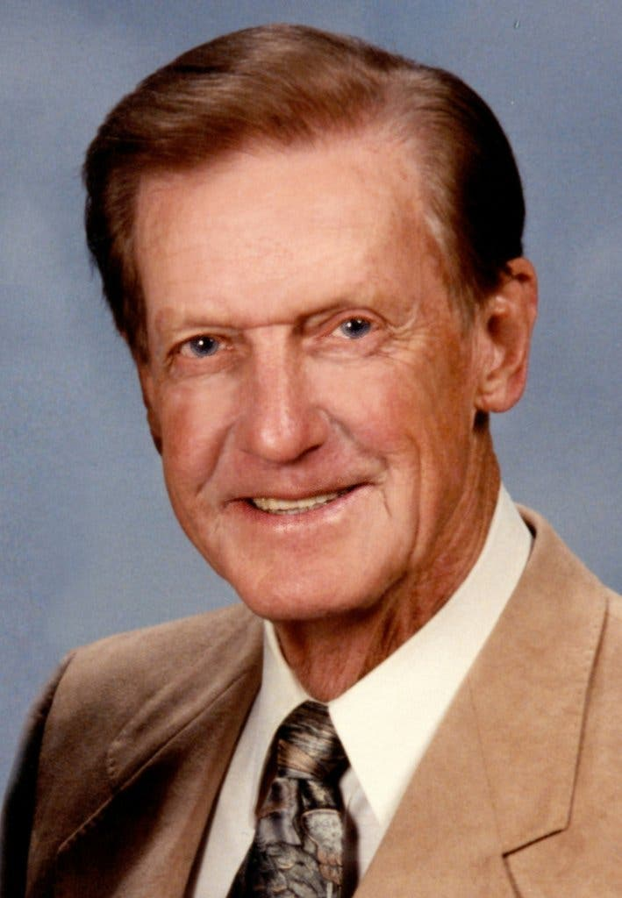

Art Gilmore

“The screen jumps for joy with Glendon Swarthout’s inside story of those uproarious Easter vacations,” Mr. Gilmore pronounced in [the trailer for “Where the Boys Are,”](http://www.youtube.com/watch?v=WCd0rPW06U8) a 1960 comedy about college girls on the make.

“Never before has any film contained such a full measure of the joy of living,” [he asserted in the trailer](http://www.youtube.com/watch?v=LJfZaT8ncYk) for Frank Capra’s life-affirming small-town tale from 1946, “It’s a Wonderful Life.”

For the 1953 science-fiction thriller “The War of the Worlds” he declared: “This could be the beginning of the end for the human race!” And in [a virtuosic bit of melodramatic recitation,](http://www.youtube.com/watch?v=D0bV2gh4E7Y) he described Alfred Hitchcock’s loopy and masterful psychodrama “Vertigo” (1958) as “the story of a love so powerful it broke through all the barriers between past and present, between life and death, between the golden girl in the dark tower and the tawdry redhead that he tried to remake in her image.”

Arthur Wells Gilmore was born in Tacoma, Wash., on March 18, 1912. His father was a bookkeeper and an insurance man who had moved west from Massachusetts with his wife shortly before his son was born. Young Arthur attended Washington State University where he worked at the campus radio station. Later, he worked at a commercial station in Seattle before moving to Los Angeles in the 1930s and becoming a staff announcer for KFWB in Hollywood. Later he moved to KNX, which was owned by CBS.

Before the era of television, he announced radio shows like “Amos ’n’ Andy,” “The Sears Radio Theater” and “Red Ryder.” He served in the Navy during World War II. For a time in the 1960s he was president of the American Federation of Television and Radio Artists, the labor union.

In 1964, on behalf of the Republican presidential candidate Barry Goldwater, he introduced a political advertisement consisting of an address by Ronald Reagan, a speech called “A Time for Choosing,” that is often cited as a factor in establishing Reagan’s influence in conservative politics.

In addition to his wife, he is survived by two daughters, Marilyn Gilmore, of Irvine, and Barbara McCoy, of Rockford, Ill., two grandchildren and four great grandchildren.

Mr. and Mrs. Gilmore, 97, met in high school and were married 72 years.

“They dated for eight years before that,” their daughter Marilyn said.

This is a more complete version of the story than the one that appeared in print.

A version of this article appears in print on Oct. 3, 2010, Section A, Page 26 of the New York edition with the headline: Art Gilmore, the Voice of Coming Attractions, Dies at 98.